**Genetics Practice Exam from summer 2021 (Gradescope) + 2 new questions**

These are examples of answers. Your answers could use different words or sentences and still obtain full marks if they contain all of the same concepts and are clear with proper terminology.

**New Questions (Summer 2022)**

**N1. Please describe the differences between Mitosis in Meiosis for the following:**

i) location of cell division and number of nuclear divisions

ii) chromosome alignment at Metaphase:

iii) number of daughter cells produced and ploidy if parent cell is diploid:

iv) genetic composition of daughter cells, i.e. are they identical to parent or unique and why?

v) Chromosome /Chromatid Separation – when does it occur:

N-2 - Please a schematic of a 2n=2 cell with the genotype (A1/A2) undergoing meiosis. Start with the cell in early Prophase I and within the cell for each phase and end with the final daughter cells.

**Practice Exam Questions from summer 2021 (from Gradescope)**

**QUESTION 1**

Consider a parent cell from a diploid organism. There are two long, two intermedia, and two short chromosomes (2n=6).

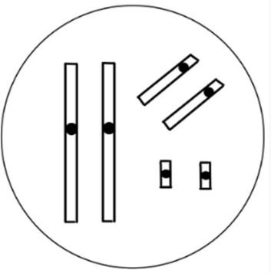

For each of the following daughter cells (Q1.1 - Q1.4), indicate whether they could be a product of the above parent cell at the end of MITOSIS, MEIOSIS I, MEIOSIS II, or NONE OF THE ABOVE. Briefly explain why each of the three options you do not select are incorrect.

Q1.1

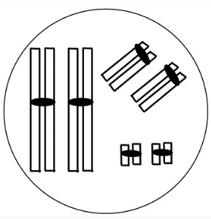

Q1.2

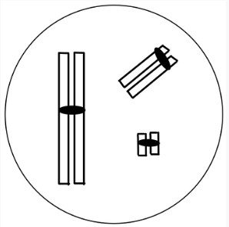

Question 1.3

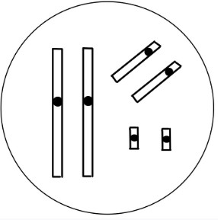

Question 1.4

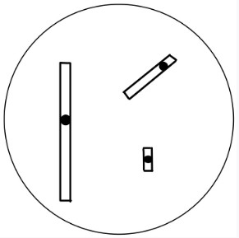

**QUESTION 2**

Consider a cell from a diploid organisms (2n=2) with the genotype A1/A2;B1/B2.

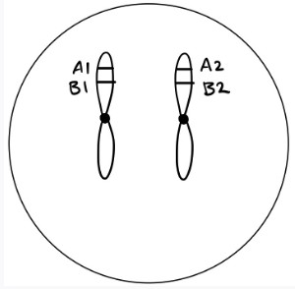

Each of the following diagrams (Q2.1 - Q2.4) represent a cell from this organism at anaphase. For each diagram, indicate whether the diagram shows chromosomes during anaphase of: MITOSIS, MEIOSIS I, MEIOSIS II, or NONE OF THE ABOVE. Briefly explain why the response you have chosen is correct (1-2 sentences).

Question 2.1

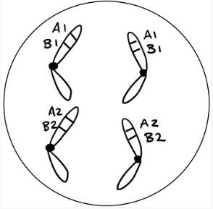

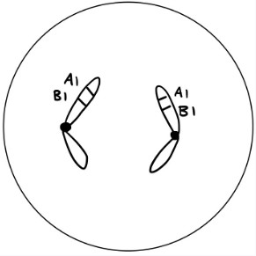Question 2.2

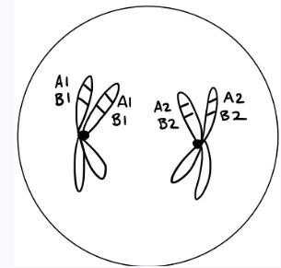Question 2.3

Question 2.4

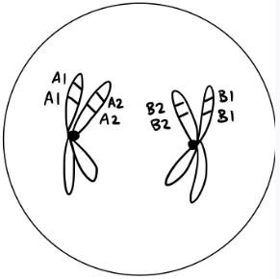

**QUESTION 3**

The figure below shows a meiotic cell at anaphase of Meiosis I.

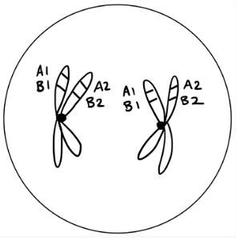

3.1 If sister chromatids are two halves of a replicated chromosome; how is it possible that the sister chromatids in this cell have different alleles? When would this change have occurred? (2 marks)

3.2

Considering the figure above, will the A and B genes assort (in gametes) independently? Briefly explain why or why not. Include a definition of independent assortment in your answer. (2 marks)

**QUESTION 4**

Briefly explain how the random combination of gametes (eggs and sperm) can contribute to genetic variation in the resulting **zygotes**. Be specific to DNA, chromosomes, homologs, etc.

**QUESTION 5**

A species of snail eating beetle in BC has an XX/XY sex determination system similar to humans. Some individuals have long antennae while others have short antennae. Their body shape can be either oval or square-shaped. Both antennae length and body shape in the beetles are heritable traits.

You are examining the mode of inheritance of these two traits. The parent for Cross 1 comes from pure breeding (true breeding or pure line) populations. One male and one female from the F1 generation were crossed to produce the F2 generation. The table below shows the phenotypes of the parents, and the F1 and F2 offspring.

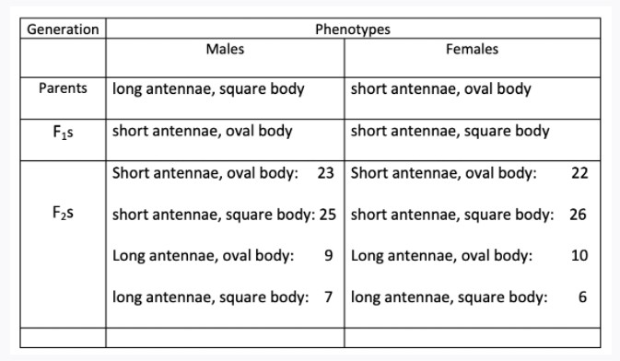

Q5.1

Which phenotype for antennae length is dominant, if applicable? Briefly explain your answer.

Question 5.2

Is antennae length an autosomal or X-linked trait in snail eating beetles? Briefly explain your answer.

Question 5.3

Looking at ONLY the antennae length trait, you perform a cross between an F1 individual above (short antennae, either a male or female) and an individual with homozygous recessive alleles on the antennae length gene; the cross produces 60 offspring. List all the antennae length phenotypes (no need to provide the phenotype info for body shape) of their offspring and their expected numbers.

Question 5.4 Which phenotype for body-shape is dominant? Briefly explain your answer.

Question 5.5 Identify the mode of inheritance for the body shape of snail eating beetles. Briefly explain your answer.

Question 5.6

Look at ONLY the body shape trait, you perform a cross between a male with oval body and a female with oval body and produce 60 progeny: 30 males and 30 females. What do you expect the progeny phenotypes to be?

# 

**QUESTION 6**

A black female mouse with normal ears is crossed with a brown male with small ears. All the F1 are black with normal ears. The F1s are self-crossed (5 crosses) and the following F2s are obtained:

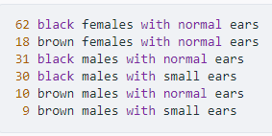

Question 6.1 What is the mode of inheritance for black fur colour in mice? Explain how you reached your conclusion for the mode of inheritance. Your answer should include evidence from the provided data to support your conclusion.

Question 6.2 It is hypothesized that normal ear size in mice has an X-linked recessive mode of inheritance. Do the data support this mode of inheritance for normal ear size in mice? Explain how you reached your conclusion. Your answer should include evidence from the data provided to support your conclusion.

**QUESTION 7**

You are studying two traits in a bird species: beak shape (B1 = blunt, B2 = pointy) and leg length (L1 = long, L2

= short). Both traits are autosomal. You perform the following cross:

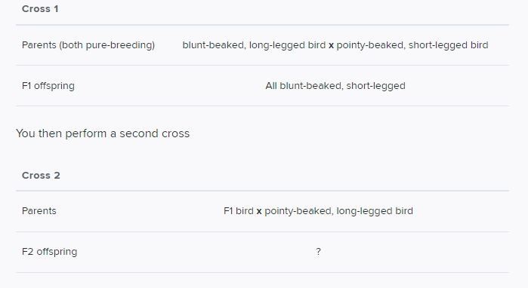

Question 7.1 Predict the relative frequency of F2 offspring phenotypes if the genes for beak shape and leg length are on different chromosomes.

Question 7.2 What phenotype(s) could be present in the F2 offspring if the genes for beak shape and leg length are on **the same chromosome** but crossing-over can occur?

Question 7.3 What are the predicted relative frequencies of the F2 offspring phenotypes if the genes for beak shape and leg length are on **the same chromosome** but crossing-over can occur? No quantification is needed.

Question 7.4 The ploidy of this species is 2n=6. Assuming that the two genes are on the same chromosome, which diagram below represents a cell from Cross 1 –blunt-beaked; long-legged parent in G1

